Purpose: Day 4 Classwork and Assignment
Date: 24/12/2025
Author: Vinayak Majhi
ID: 58618

Classwork
(Notepad)

Q.1. Write a C++ program to declare 3 pointer variables of three different data types and initialize them with their respective variable address.

#include <iostream>
using namespace std;

int main() {
int a = 10;
float b = 3.14f;
double c = 9.81;

int *iPtr = &a;
float *fPtr = &b;
double *dPtr = &c;

// iPtr = dPtr;

cout << "Address stored in iPtr: " << iPtr << endl;
cout << "Address stored in fPtr: " << fPtr << endl;
cout << "Address stored in dPtr: " << dPtr << endl;

return 0;
}

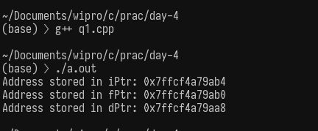
Q.2. Combine the given 2 programs.
1. rand() usage and
2. dynamic array with user given size.
Create a dynamic array with user given size, and fill the array with random values using rand(). Print the array.

#include <cstdlib>
#include <ctime>
#include <iostream>

using namespace std;

int main() {
int n;
cout << "Enter size: ";
cin >> n;

int *arr = new int[n];

srand(time(0));

for (int i = 0; i < n; i++) {
arr[i] = rand() % 100;
cout << arr[i] << " ";
}

delete[] arr;
return 0;
}

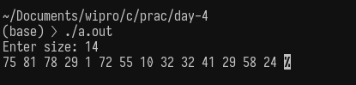

Q.3. Use the previous question as data, find the sum and average of the array data.
#include <cstdlib>
#include <ctime>
#include <iostream>

using namespace std;

int main() {
int n, sum = 0;
cout << "Enter size: ";
cin >> n;

int *arr = new int[n];
srand(time(0));

for (int i = 0; i < n; i++) {
arr[i] = rand() % 100;
sum += arr[i];
cout << arr[i] << " ";
}

float avg = (float)sum / n;

cout << "\nSum = " << sum;
cout << "\nAverage = " << avg;

delete[] arr;
return 0;
}

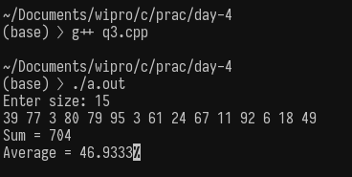

Q.4. Find the largest and smallest number from the 2 question logic.
#include <cstdlib>
#include <ctime>
#include <iostream>

using namespace std;

int main() {
int n;
cout << "Enter size: ";
cin >> n;

int *arr = new int[n];
srand(time(0));

for (int i = 0; i < n; i++) {
arr[i] = rand() % 100;
cout << arr[i] << " ";
}

int max = arr[0], min = arr[0];

for (int i = 1; i < n; i++) {
if (arr[i] > max)
max = arr[i];
if (arr[i] < min)
min = arr[i];
}

cout << "\nLargest = " << max;
cout << "\nSmallest = " << min;

delete[] arr;
return 0;
}

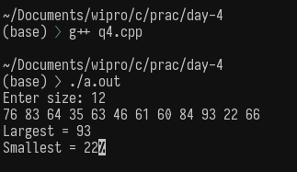

Q.5. Reverse the data stored in dynamic array.

#include <cstdlib>
#include <ctime>
#include <iostream>

using namespace std;

int main() {
int n;
cout << "Enter size: ";
cin >> n;

int *arr = new int[n];
srand(time(0));

for (int i = 0; i < n; i++) {
arr[i] = rand() % 100;
cout << arr[i] << " ";
}

for (int i = 0; i < n / 2; i++) {
int temp = arr[i];
arr[i] = arr[n - i - 1];
arr[n - i - 1] = temp;
}

cout << "\nReversed array:\n";
for (int i = 0; i < n; i++) {
cout << arr[i] << " ";
}

delete[] arr;
return 0;
}

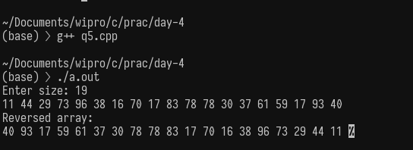

Q6. Sort the dynamic array created with question #2 logic.

#include <cstdlib>
#include <ctime>
#include <iostream>

using namespace std;

int main() {
int n;
cout << "Enter size: ";
cin >> n;

int *arr = new int[n];
srand(time(0));

for (int i = 0; i < n; i++) {
arr[i] = rand() % 100;
cout << arr[i] << " ";
}

for (int i = 0; i < n - 1; i++) {
for (int j = 0; j < n - i - 1; j++) {
if (arr[j] > arr[j + 1]) {
int temp = arr[j];
arr[j] = arr[j + 1];
arr[j + 1] = temp;
}
}
}

cout << "\nSorted array:\n";
for (int i = 0; i < n; i++) {
cout << arr[i] << " ";
}

delete[] arr;
return 0;
}

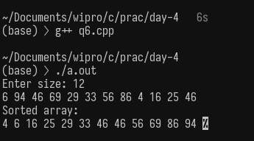

Q.7. Try implementing 2 D dynamic array.

#include <iostream>
using namespace std;

int main() {
int rows, cols;

cout << "Enter rows: ";
cin >> rows;
cout << "Enter columns: ";
cin >> cols;

int **arr = new int *[rows];
for (int i = 0; i < rows; i++) {
arr[i] = new int[cols];
}

cout << "Enter elements:\n";
for (int i = 0; i < rows; i++) {
for (int j = 0; j < cols; j++) {
cin >> arr[i][j];
}
}

cout << "\n2D Array:\n";
for (int i = 0; i < rows; i++) {
for (int j = 0; j < cols; j++) {
cout << arr[i][j] << " ";
}
cout << endl;
}

for (int i = 0; i < rows; i++) {
delete[] arr[i];
}
delete[] arr;

return 0;

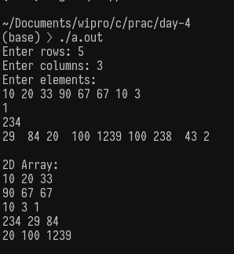

Q.8. Insert a new element into a dynamically allocated array(Created using question #2).
#Remember inserting or deleting at a position needs reallocation/resizing of the memory.

#include <cstdlib>
#include <ctime>
#include <iostream>

using namespace std;

int main() {
int n, pos, value;

cout << "Enter size: ";
cin >> n;

int *arr = new int[n];
srand(time(0));

for (int i = 0; i < n; i++) {
arr[i] = rand() % 100;
cout << arr[i] << " ";
}

cout << "\nEnter position to insert (0 to " << n << "): ";
cin >> pos;
cout << "Enter value: ";
cin >> value;

int *newArr = new int[n + 1];

for (int i = 0; i < pos; i++) {
newArr[i] = arr[i];
}

newArr[pos] = value;

for (int i = pos; i < n; i++) {
newArr[i + 1] = arr[i];
}

cout << "\nAfter insertion:\n";
for (int i = 0; i < n + 1; i++) {
cout << newArr[i] << " ";
}

delete[] arr;
delete[] newArr;

return 0;
}

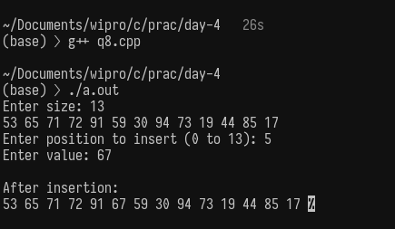

Q.9 9. Delete an element from dynamically allocated array(Created using question #2).

#include <cstdlib>
#include <ctime>
#include <iostream>

using namespace std;

int main() {
int n, pos;

cout << "Enter size: ";
cin >> n;

int *arr = new int[n];
srand(time(0));

for (int i = 0; i < n; i++) {
arr[i] = rand() % 100;
cout << arr[i] << " ";
}

cout << "\nEnter position to delete (0 to " << n - 1 << "): ";
cin >> pos;

int *newArr = new int[n - 1];

for (int i = 0; i < pos; i++) {
newArr[i] = arr[i];
}

for (int i = pos + 1; i < n; i++) {
newArr[i - 1] = arr[i];
}

cout << "\nAfter deletion:\n";
for (int i = 0; i < n - 1; i++) {
cout << newArr[i] << " ";
}
delete[] arr;
delete[] newArr;
return 0;
}
